**VLAN for 4 switch:**

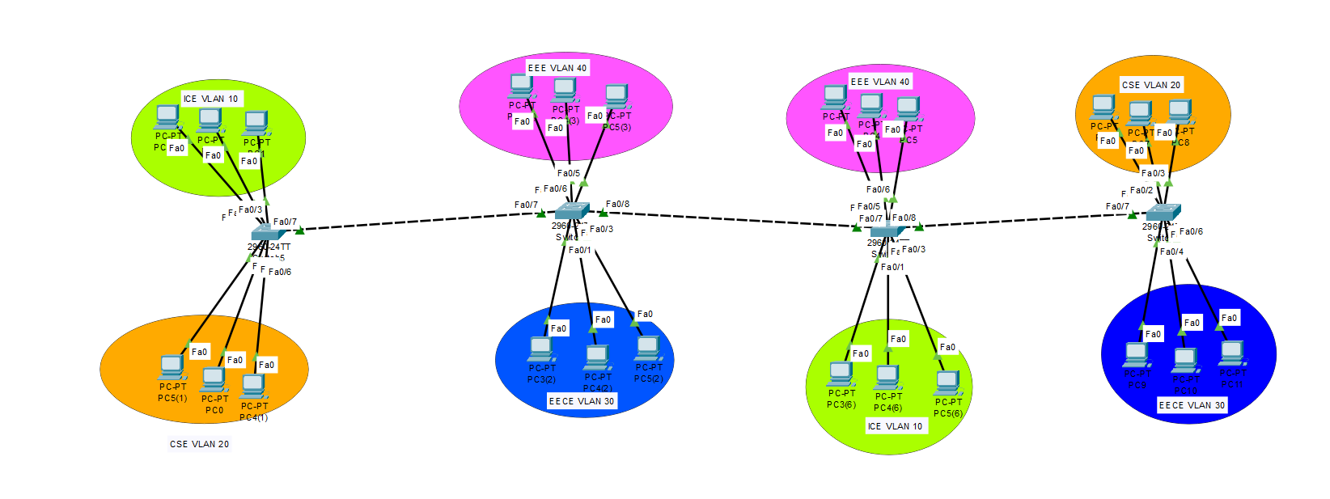

Switch 1 CLI

|  |
| --- |
| Switch>en  Switch#conf t  Enter configuration commands, one per line. End with CNTL/Z.  Switch(config)#vlan 10  Switch(config-vlan)#name ICE  Switch(config-vlan)#exit  Switch(config)#vlan 20  Switch(config-vlan)#name CSE  Switch(config-vlan)#exit  Switch(config)#interface range fastethernet 0/1-3  Switch(config-if-range)#switchport mode access  Switch(config-if-range)#switchport access vlan 10  Switch(config-if-range)#exit  Switch(config)#interface range fastethernet 0/4-6  Switch(config-if-range)#switchport mode access  Switch(config-if-range)#switchport access vlan 20  Switch(config-if-range)#exit  Switch(config)#interface fastethernet 0/7  Switch(config-if)#switchport mode trunk  Switch(config-if)#switchport trunk allowed vlan 10,20,30,40  Switch(config-if)#exit  Switch(config)#end  Switch#wr  Building configuration...  [OK]  Switch# |

Switch 2

|  |
| --- |
| Switch>en  Switch#conf t  Enter configuration commands, one per line. End with CNTL/Z.  Switch(config)#vlan 30  %LINEPROTO-5-UPDOWN: Line protocol on Interface FastEthernet0/7, changed state to down  %LINEPROTO-5-UPDOWN: Line protocol on Interface FastEthernet0/7, changed state to up  Switch(config-vlan)#name EECE  Switch(config-vlan)#exit  Switch(config)#vlan 40  Switch(config-vlan)#name EEE  Switch(config-vlan)#exit  Switch(config)#interface range fastethernet 0/1-3  Switch(config-if-range)#switchport mode access  Switch(config-if-range)#switchport access vlan 30  Switch(config-if-range)#exit  Switch(config)#interface range fastethernet 0/4-6  Switch(config-if-range)#switchport mode access  Switch(config-if-range)#switchport access vlan 40  Switch(config-if-range)#exit  Switch(config)#interface fastethernet 0/7  Switch(config-if)#switchport mode trunk  Switch(config-if)#switchport trunk allowed vlan 10,20,30,40  Switch(config-if)#exit  Switch(config)#interface fastethernet 0/8  Switch(config-if)#switchport mode trunk  Switch(config-if)#  %LINEPROTO-5-UPDOWN: Line protocol on Interface FastEthernet0/8, changed state to down  %LINEPROTO-5-UPDOWN: Line protocol on Interface FastEthernet0/8, changed state to up  Switch(config-if)#switchport trunk allowed vlan 10,20,30,40  Switch(config-if)#exit  Switch(config)#end  Switch#  %SYS-5-CONFIG_I: Configured from console by console  wr  Building configuration...  [OK]  Switch# |

Switch 3

|  |
| --- |
| Switch>  Switch>en  Switch#conf t  Switch(config)#vlan 10  Switch(config-vlan)#name ICE  Switch(config-vlan)#exit  Switch(config)#vlan 40  Switch(config-vlan)#name EEE  Switch(config-vlan)#exit  Switch(config)#interface range fastethernet 0/1-3  Switch(config-if-range)#switchport mode access  Switch(config-if-range)#  Switch(config-if-range)#switchport access vlan 10  Switch(config-if-range)#exit  Switch(config)#interface range fastethernet 0/4-6  Switch(config-if-range)#switchport mode access  Switch(config-if-range)#switchport access vlan 40  Switch(config-if-range)#exit  Switch(config)#interface fastethernet 0/7  Switch(config-if)#switchport mode trunk  Switch(config-if)#switchport trunk allowed vlan 10,20,30,40  Switch(config-if)#exit  Switch(config)#interface fastethernet 0/8  Switch(config-if)#switchport mode trunk  Switch(config-if)#  %LINEPROTO-5-UPDOWN: Line protocol on Interface FastEthernet0/8, changed state to down  %LINEPROTO-5-UPDOWN: Line protocol on Interface FastEthernet0/8, changed state to up  Switch(config-if)#switchport trunk allowed vlan 10,20,30,40  Switch(config-if)#exit  Switch(config)#end  Switch#  %SYS-5-CONFIG_I: Configured from console by console  Switch#wr  Building configuration...  [OK]  Switch# |

Switch 4

|  |
| --- |
| Switch>en  Switch#conf t  Enter configuration commands, one per line. End with CNTL/Z.  Switch(config)#  %LINEPROTO-5-UPDOWN: Line protocol on Interface FastEthernet0/7, changed state to down  %LINEPROTO-5-UPDOWN: Line protocol on Interface FastEthernet0/7, changed state to up  Switch(config)#vlan 20  Switch(config-vlan)#name CSE  Switch(config-vlan)#exit  Switch(config)#vlan 30  Switch(config-vlan)#name EECE  Switch(config-vlan)#exit  Switch(config)#interface range fastethernet 0/1-3  Switch(config-if-range)#switchport mode access  Switch(config-if-range)#switchport access vlan 20  Switch(config-if-range)#exit  Switch(config)#interface range fastethernet 0/4-6  Switch(config-if-range)#switchport mode access  Switch(config-if-range)#switchport access vlan 30  Switch(config-if-range)#exit  Switch(config)#interface fastethernet 0/7  Switch(config-if)#switchport mode trunk  Switch(config-if)#switchport trunk allowed vlan 10,20,30,40  Switch(config-if)#exit  Switch(config)#end  Switch#  %SYS-5-CONFIG_I: Configured from console by console  Switch#wr  Building configuration...  [OK]  Switch# |